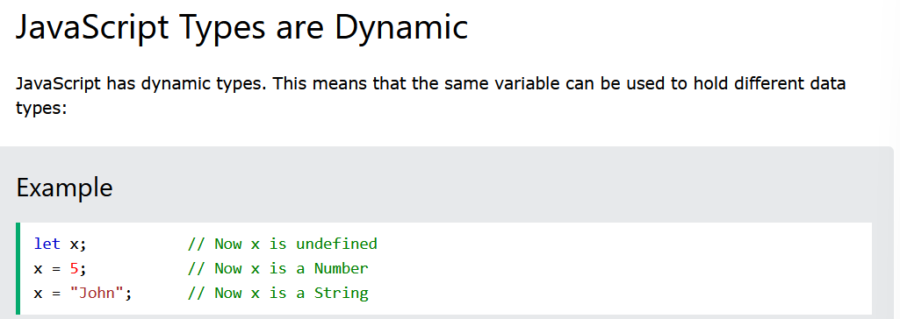

**Strings**

**Numbers**

**Booleans**

**Arrays,**

**Objects**

**Undefined**

Actually, Array is an Object

If we do, typeof(array_name) ; it will give object



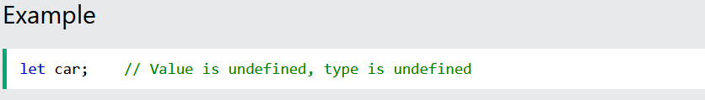

**These are the most commonly used data types in Java Script**

**We can find data type by using typeof operator**